Experiment 2 – Questionnaire

Consent1 - Thank you very much for participating in this survey. We are interested in your opinion about using credit cards, which allow the acquisition of products and services through debt that must be paid off later. We appreciate your time and dedication in sharing your opinion. The survey will take about 4 minutes. All answers are anonymous and confidential. Please answer the following question before you start:

I confirm I am over 18 years old, my participation is voluntary, and I know I can terminate my participation at any time.

* Yes
* No

ProlificID - What is your Prolific IDPlease note that this response should auto-fill with the correct ID

Q145 - Now, we will check if you are eligible to participate in this survey

CountryResidence - In which country do you currently reside?

▼ United States of America ... Zimbabwe

CreditCardOwned - Which of these credit cards do you own? You can select more than one option.

* Visa
* MasterCard
* American Express
* Other
* ⊗None

Intro - On the next screen, you will find information about a credit card payment. Imagine it is your card, and you are about to make your monthly payment. Considering this scenario, decide how much to pay.

Please continue to view the payment website.

[Standard Payment Baseline Screen]

Which payment option will you choose?:

* Statement balance
* Minimum payment
* Other amount ($) __________________________________________________

|  |  |
| --- | --- |
|  |  |

[Statement Balance Treatment Screen]

Which payment option will you choose?:

* Statement balance
* Minimum payment
* Other amount ($) __________________________________________________

|  |  |
| --- | --- |
|  |  |

[Table Treatment Screen]

Which payment option will you choose?:

* Statement balance
* Minimum payment
* Other amount ($) __________________________________________________

|  |  |
| --- | --- |
|  |  |

[Slider – Low Treatment Screen]

Which payment option will you choose?:

* Statement balance
* Minimum payment
* Other amount ($) __________________________________________________

|  |  |
| --- | --- |
|  |  |

[Slider – High Treatment Screen]

Which payment option will you choose?:

* Statement balance
* Minimum payment
* Other amount ($) __________________________________________________

S1 - How confident are you that the decision you made regarding the payment amount was the right one?

|  |  |  |  |  |  |  |  |
| --- | --- | --- | --- | --- | --- | --- | --- |
|  | Extremely unconfident | Very unconfident | Unconfident | Neither confident nor unconfident | Confident | Very confident | Extremely confident |
|  |  |  |  |  |  |  |  |

LateFees_Intro - For the upcoming two questions, you'll be provided with fictional credit card statements. Answer to the best of your ability, and if you are unsure, feel free to indicate so.

LateFees1 - Given the following credit card statement: 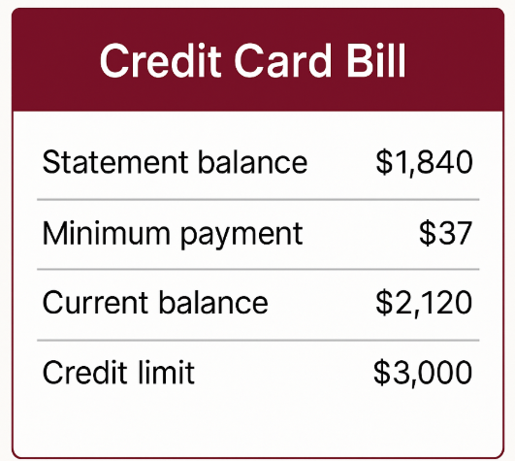

Please indicate the lowest amount that should be paid to avoid late fees, even if interest charges must be paid.

* $0
* $37
* $1,840
* $2,120
* $3,000
* It is not possible to know this information
* I am not sure

LateFees2 - Given the following credit card statement: 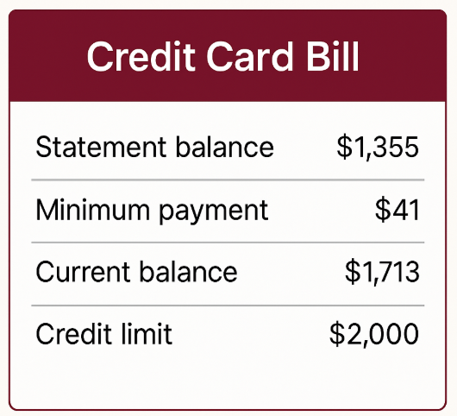

Please indicate the lowest amount that must be paid to avoid interest charges.

* $0
* $41
* $1,355
* $1,713
* $2,000
* It is not possible to know this information
* I am not sure

FL Intro - The following three questions aim to measure certain financial concepts. Answer to the best of your ability, and if you are unsure, feel free to indicate so.

FL1 - Suppose you had $100 in a savings account and the interest rate was 2% per year. After 5 years, how much do you think you would have in the account if you left the money to grow?

* More than $102
* Exactly $102
* Less than $102
* Don’t know
* Refuse to answer

FL2 - Imagine that the interest rate on your savings account was 1% per year and inflation was 2% per year. After 1 year, with the money in this account, would you be able to buy…

* More than today
* Exactly the same as today
* Less than today
* Don’t know
* Refuse to answer

FL3 - Do you think the following statement is true or false? Buying a single company stock usually provides a safer return than a stock mutual fund.

* True
* False
* Don’t know
* Refuse to answer

DebtAversion1 - To what extent do you agree or disagree with the following statements?

|  |  |  |  |  |  |  |  |
| --- | --- | --- | --- | --- | --- | --- | --- |
|  | Strongly disagree | Disagree | Somewhat disagree | Neither agree nor disagree | Somewhat agree | Agree | Strongly agree |
| I am the type of person who enjoys spending money in the present and then figures out how to manage in the future |  |  |  |  |  |  |  |
| I am the type of person who prefers to live without getting into debt or borrowing money |  |  |  |  |  |  |  |

DemographicsIntro - Finally, please answer the following three questions about yourself.

Demo_UsualPayment - What's your typical credit card bill payment in the last 12 months?

* The full statement balance
* An amount between the minimum payment and the statement balance
* Only the minimum payment
* Less than the minimum payment

Demo_Education - What is the highest level of education you have achieved?

* Less than a high school diploma or equivalent
* High school graduate
* Some college but no degree
* Bachelor's degree
* Advanced degree (Master's degree, professional degree, or doctoral degree)

Demo_Income - What is your household's annual income?

* $24,999 or under
* $25,000 to $44,999
* $45,000 to $64,999
* $65,000 to $94,999
* $95,000 to $134,999
* $135,000 to $249,999
* $250,000 or over

End Prolific - Thank you for participating in this study. Please click the button below to be redirected back to Prolific and register your submission.

Free1 - Thank you for your participation. Now that you have finished the survey, we invite you to optionally share a final reflection about the survey.

When you were first presented with a credit card statement in this survey, what factors did you consider when deciding how much to pay?

________________________________________________________________

________________________________________________________________

________________________________________________________________

________________________________________________________________

________________________________________________________________

Free2 - Do you have any general comments about the survey? Any question that was difficult to understand?

________________________________________________________________

________________________________________________________________

________________________________________________________________

________________________________________________________________

________________________________________________________________